Build the linux dual stack Router

Mark
2010-01-30

CONFIDENTIALITY STATEMENT
The information presented in this document is strictly confidential and supplied on the understanding that it will be handled as confidential material. Disclosure of any part of this document to third parties, without the prior written consent from the author, is prohibited.
0. Document Information

Revision History
Date | Version | Author | Description
2009-7-29 | 0.1 | Mark | Build an Linux IPv6 Router

Related Documents
Date | Author | Document | Version

Content

Build an Linux IPv6 Router 1
Revision History 2
Related Documents 2
Content 3
1. Overview 4
2. Compile a new kernel 4
2.1 Check with IPv6 Install 4
2.2 Check with RADVD Install 4
3. Configure Router 5
3.1 Topology: 5
3.2 Linux interface configure: 5
3.3 Linux Radvd deamon configure: 6
3.4 Linux Ipv6 forwarding configure. 6
4. Limitation 7
5. Reference 7

1. Overview
In this SOP, we try to simulate a CPE Router with Linux PC which contained two network cards.

2. Compile a new kernel

2.1 Check with IPv6 Install
To check, whether your current running Linux kernel supports IPv6, take a look into your /proc-file-system. Following entry must exist:.
/proc/net/if_inet6
A short automatical test looks like:
# test –f /proc/net/if_inet6 && echo “Ipv6 is ready”

2.2 Check with RADVD Install
To check, whether your current running Linux supports IPv6 RADVD, take a look into your /proc-file-system. Following entry must exist.
/etc/init.d/radvd
/etc/radvd.conf

If you don’t install the radvd daemon, please install it first and you can refer: http://www.litech.org/radvd/

3. Configure Router

3.1 Topology:
First configure your IPv6 interface and setup the appropriate route. Since our Test lab topology is like as following:

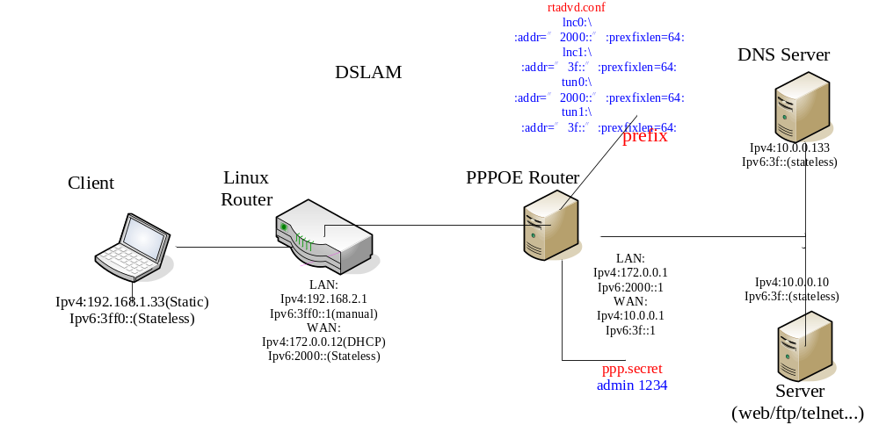

3.2 Linux interface configure:
In my example this is done like this CPE, so add following in the linux:
ip a a 3ff0::1 dev eth0
ip r a 3ff0::/64 dev eth0
ip r a 2000::/64 via eth1 # Here, the eth1 is connect with ISP directly.
#ip r a 2000::/64 via 2000::1 (ISP’s ipv6-address.)
Enter /etc/sysconfig/network-scripts and edit the configure file ifcfg-eth0, the result should be like as:
DEVICE=eth0
BOOTPROTO=none
BROADCAST=192.168.2.255
IPADDR=192.168.2.1
NETMASK=255.255.255.0
NETWORK=192.168.2.0
ONBOOT=yes
HWADDR=00:0c:29:70:fe:e8
TYPE=Ethernet
USERCTL=no
PEERDNS=yes
IPV6INIT=no
NM_CONTROLLED=no
Enter /etc/sysconfig/network-scripts and edit the configure file ifcfg- eth1, the result should be like as:
DEVICE=eth1
BOOTPROTO=none
BROADCAST=172.0.255.255
IPADDR=172.0.0.12
NETMASK=255.255.0.0
NETWORK=172.0.0.0
ONBOOT=yes
HWADDR=00:0c:29:70:fe:f2
GATEWAY=172.0.0.1
TYPE=Ethernet
USERCTL=no
PEERDNS=yes
IPV6INIT=no
NM_CONTROLLED=no
You can also add these two lines to the beginning of /etc/rc.local to make them execute during boot time.

3.3 Linux Radvd deamon configure:
After installing radvd, the configuration file should look like this:
interface eth0 /*eth0 is the LAN side, and we just send the RA to LAN*/
{
AdvSendAdvert on;
MinRtrAdvInterval 5;
MaxRtrAdvInterval 15;

prefix 2001:468:181:f100::/64
{
AdvOnLink on;
AdvAutonomous on;
};
};

interface eth1,eth2,etc .... // if we wish to advertise on a second interface
{
};
The reason MinRtrAdvInterval and MaxRtrAdvInterval are necessary is because there is a glitch in the Microsoft implementation of IPv6 (at least at the time of this writing) that prevents the host from sending Router Solicitation messages after boot even if the host has IPv6 enabled (it works as it should, if you bring the interface down and then up again). If these settings would not be present in the config file, the default prefix broadcast interval is 10 minutes, and your users would either have to wait until the next broadcast for their computers to get their IPv6 addresses or bring their network interfaces down and then back up again manually (and that's a hassle, and no one likes hassle). You can find dozens more options to configure by typing 'man radvd.conf'.
For radvd to be able to start IPv6 routing must be enabled. You do this by typing:

3.4 Linux router forwarding configure.
Enter /etc and edit the configure file sysctl.conf, append following:
net.ipv4.ip_forwarding=1
#sysctl -w net.ipv6.conf.all.forwarding=1
net.ipv6.conf.all.forwarding=1
Add the line 'net.ipv6.conf.all. forwarding=1' to /etc/sysctl.conf to make this be applied during startup.
If you have a native IPv6 connection to your upstream provider your job is simple. Route packets to the next hop router. If the address of your ISP's router is 2001:468:181:ff::1, you type the following command (add to /etc/rc.local to make it be executed at boot time):

4. Limitation
- LAN PC must be set static Ipv4 address;
- Must start RADVD server manually;
  - “/etc/init.d/radvd start” or “/etc/init.d/radvd restart”.
- For total topology, need add following static router:
  - “/etc/init.d/radvd start” in BRAS device.
  - “route add –inet6 3ff0::/64 2000::12” in BRAS device
  - “rtadvd –c /etc/rtadvd.conf ln0” in BRAS device
  - “rtadvd –c /etc/rtadvd.conf ln0” in BRAS device

5. Reference
1. http://lucastomicki.net/ipv6.router.php
2. Linux Ipv6 HOWTO, section7.4.1.
Refer: (http://www.uibk.ac.at/linuxdoc/LDP/HOWTO/Linux+IPv6-HOWTO/)
3. RADVD: http://www.litech.org/radvd/

